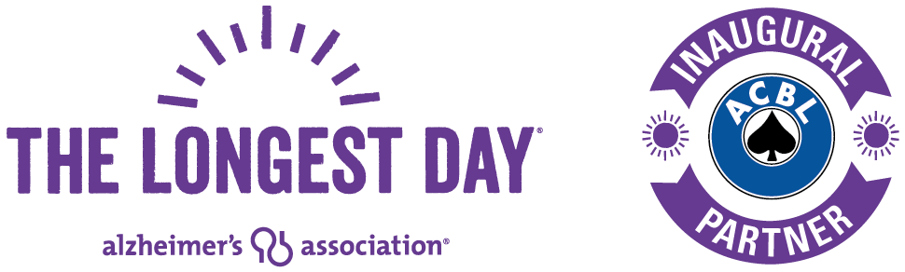

[LOCAL MEDIA CONTACT NAME] Lori Pope
[CLUB NAME] American Contract Bridge League
[EMAIL ADDRESS] lori.pope@acbl.org
[PHONE NUMBER] 662-253-3109

LOCAL BRIDGE PLAYERS FIGHT ALZHEIMER’S

[CLUB NAME] holds fundraiser for Alzheimer’s Association® event The Longest Day®

[CITY, STATE], [RELEASE DATE] – [CLUB NAME], an American Contract Bridge League (ACBL) club, will play a marathon of bridge on [EVENT DATE] and host a fundraiser as part of The Longest Day® to benefit the Alzheimer’s Association®.

[CLUB NAME] will hold duplicate bridge games from [START TIME] until [END TIME]. All bridge players are welcome, as tables for social groups will be available throughout the day. No bridge experience is necessary to attend the beginner lesson.

“We’re playing bridge because studies have shown maintaining strong social connections and keeping mentally active could delay cognitive decline and possibly dementia as we age,” said [CLUB MANAGER NAME], club manager. “We want to invite the entire community to come play if you know how or come learn if you don’t.”

More than 5 million Americans are living with Alzheimer’s disease, and that number is expected to triple by 2050. The Longest Day encourages people around the world to participate in an activity they love to honor someone facing the disease.

As a global partner of The Longest Day, the ACBL has supported hundreds of bridge clubs across the country for six years to raise awareness and funds for Alzheimer’s disease. So far, bridge players have raised more than $3.5 million for the Alzheimer’s Association.

[INSERT QUOTE FROM LOCAL ALZHEIMER’S ASSOCIATION REPRESENTATIVE ABOUT THE ACBL’S INVOLVEMENT IN THE CAMPAIGN]

EXAMPLE: “The dedication by American Contract Bridge League to The Longest Day in communities across the country remains unwavering, especially here in [CITY]” said [INSERT NAME], [INSERT TITLE] for the Alzheimer's Association [INSERT CHAPTER NAME}. “It is the support of ACBL and all those participating in The Longest Day that will help change the trajectory of Alzheimer's disease for millions.”

For more information and to join the fun visit [WEB LINK] or contact [CLUB CONTACT NAME PHONE NUMBER AND E-MAIL ADDRESS].

About the ACBL
Founded in 1937, the ACBL is the largest bridge organization in the world, serving 167,000 members, 3,200 bridge clubs and sanctioning 1,100 sectional and regional tournaments annually. The ACBL's three North American Bridge Championships each attract up to 5,000 players representing every state in the United States, Canada and about 20 other foreign countries. A challenging and rewarding card game, bridge attracts players of all ages and walks of life – from Bill Gates and Warren Buffett to astronaut Greg “Box” Johnson. For more information about the ACBL, visit www.acbl.org.

About the Alzheimer’s Association®
The Alzheimer’s Association is the world’s leading voluntary health organization in Alzheimer's care, support and research. Our mission is to eliminate Alzheimer’s disease through the advancement of research; to provide and enhance care and support for all affected; and to reduce the risk of dementia through the promotion of brain health. Our vision is a world without Alzheimer’s. Visit alz.org or call 800.272.3900.

# # #

