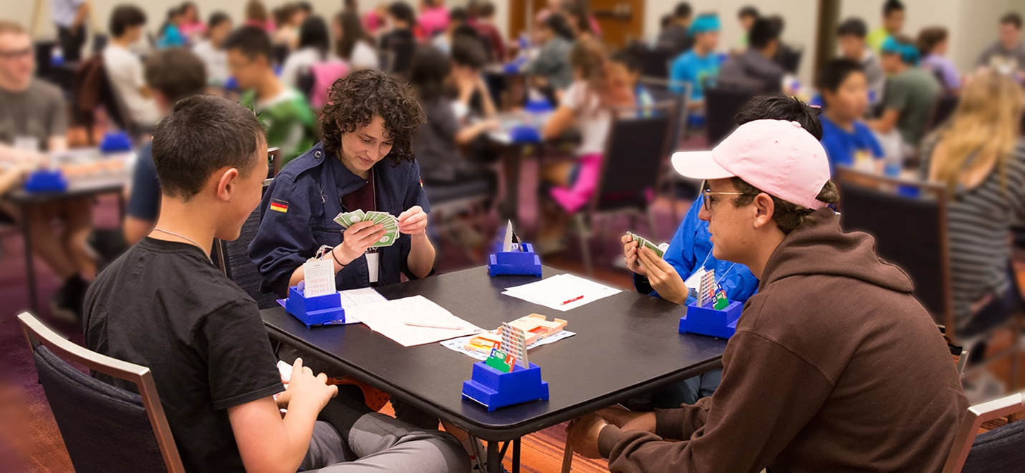

Want to play a game?
To replace the photo with your own, just right click on the image and select change picture. Then find your image and click insert.

If you’re ready to write, just select a line of text and start typing. For best results, don’t include space to the right of the characters in your selection.

