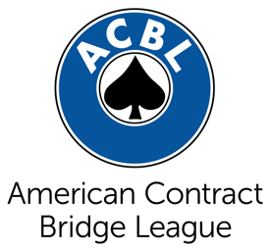
FOR IMMEDIATE RELEASE
[insert date]
Contact: [insert contact name]
Title: [insert contact title]
Phone: [insert number]
Email: [insert email address]

Gatlinburg Bridge Tournament Attracts Players Nationwide
[This is an example title. Title your release accordingly with the most important information.]

CITY, State – The opening paragraph should begin with a statement about WHAT you want the public to know, WHEN and WHERE, and last WHY the media should care to tell them– impact statements work best. Next you want to let the public know WHO the event is for.

Example: GATLINBURG, Tenn. – Thousands of bridge players from across North America will gather in Gatlinburg for the 12th Annual Smoky Mountain Gatlinburg Regional at the Gatlinburg Convention Center, April 16 to April 22. While visiting Gatlinburg, players hope to return home with masterpoints – the metric of accomplishment in the world of bridge – but with lodging, dining out and sight-seeing, all will leave behind them revenue. With speakers, novice games and lessons, the bridge tournament has something for everyone who may wish to attend.

Next insert a quote from an official. This can be an official within the community about how they are pleased to welcome back the tournament, or it can be from a tournament chair about how they are excited about the event and all it has to offer.

Example: “With more than 8,000 tables, the Gatlinburg Regional is one of the largest regional bridge tournaments in the Nation,” said John Smith, tournament chair. “The top-level bridge play combined with the hospitality and beautiful scenery in Gatlinburg is no doubt what draws so many here every year.”

If you have anything special you would like to feature, this would be the paragraph.

Example: Included in this year’s schedule of events is a Junior Workshop where bridge teachers can learn how to teach the game of bridge to the youth of today. Atlanta Junior Bridge’s Patty Tucker will be on hand to lead the workshop. Educators are invited to attend so they may learn about the educational and social benefits bridge offers their students.

Last you want to sum up the press release. Once again, let the reader know why this is important to the general public and tell them where they can find out more information.

Example: The Gatlinburg Regional is a bridge tournament sanctioned by the American Contract Bridge League. Most visitors stay the duration of the seven-day tournament, which is why the economic impact on the city is so great. For more information about the Gatlinburg Regional and full schedule of events, visit http://gatlinburgregional.org/.

###

