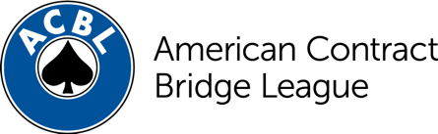
Calendar Listing

Come flex your card skills at the [INSERT NAME OF TOURNAMENT], a bridge tournament sanctioned by the American Contract Bridge League. Bridge players of all skill levels are invited to attend, especially local social players. The tournament not only has opportunities daily for bridge play, but guest speakers and lessons for social players and those new to duplicate bridge. Game fees are only [INSERT PRICE OF GAME] and all lessons and lectures are free! Contact [INSERT CONTACT NAME, PHONE NUMBER AND WEB ADDRESS HERE] for more information on how to participate and join the fun.

CONTACT: (Insert Publicity Chair Name Here)
(Insert Tournament Name)
(Insert email) (Insert phone #)

About the ACBL
Founded in 1937, the ACBL is the largest bridge organization in the world, serving 167,000 members and 3,000 bridge clubs and sanctioning 1,100 sectional and regional tournaments annually. The ACBL’s three North American Bridge Championships each attract up to 6,500 players from all around the world. A challenging and rewarding card game, bridge draws players of all ages and walks of life – from Bill Gates and Warren Buffett to astronaut Greg “Box” Johnson and Jeopardy champion James Holzhauer. For more information about the ACBL, visit acbl.org.

