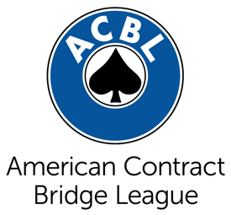
FOR IMMEDIATE RELEASE
[insert date]
Contact: [insert contact name]
Title: [insert contact title]
Phone: [insert number]
Email: [insert email address]

School Bridge Club Leads to Fun, Improved Grades for Students
[This is an example title. Give your release a catchy title with the most important information.]

CITY, State – The opening paragraph should begin with a bold statement about what you want the public to know and why it’s interesting.

Example: HORN LAKE, Miss. – A new after-school activity is finding success at Liberty Middle School – bridge club. Twice a week, a teacher from ABC Junior Bridge shows more than a dozen students how to play the card game bridge. Parents say they already see the benefits, from a fun new pastime to better grades in school.

Next, insert a quote from an official further explaining the introductory paragraph.

Example: “With two sets of partners, bridge is a social game, but it’s also a mental challenge,” said bridge teacher June Smith. “You’re using math and logic skills to gauge the strength of your hand compared to other players’ hands.”

Explain a little bit more about how bridge is played.

Example: Bridge is played with a standard deck of playing cards and four players comprised of two partnerships. Duplicate bridge differs from other forms of bridge because the same deal (i.e., the specific arrangement of the cards into the four hands) is played at each table, and scoring is based on relative performance. This way, the element of skill is heightened while that of chance is reduced.

Insert a quote from a participant (or parent of participant).

Example: “In the few months my son has been learning to play bridge, I’ve noticed several positive changes in him,” said Carolyn Turner, parent of a bridge club member. “Not only does his teacher say he is showing more confidence in the classroom, he’s made a lot of new friends!”

Close with a statement about how the public can start a youth bridge program.

Example: ABC Junior Bridge teaches youth classes at local schools, churches and community centers. For more information on how to start a program, visit abcjuniorbridge.com or call June Smith at xxx-xxx-xxxx.

###

