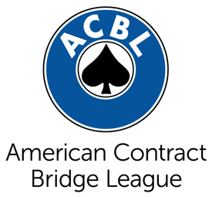
FOR IMMEDIATE RELEASE
[insert date]
Contact: [insert contact name]
Title: [insert contact title]
Phone: [insert number]
Email: [insert email address]

Local Club Celebrates 30 Years of Bridge Games in West Falls
[This is an example title. Give your release a catchy title with the most important information.]

CITY, State – The opening paragraph should begin with a bold statement about what you want the public to know and why it’s interesting.

Example: WEST FALLS, Idaho – For the last 30 years in West Falls, hundreds of players have been meeting at the Diamonds & Spades Bridge Club to play the ultimate card game – bridge.

Next, insert a quote from an official further explaining the introductory paragraph.

Example: “Players keep returning to the club because bridge is both fun and challenging,” said Martha Jones, the manager at Diamonds & Spades. “Many of the members get quite competitive, but it’s also a great way to make friends.”

Explain a little bit more about how bridge is played.

Example: Bridge is played with a standard deck of playing cards and four players comprised of two partnerships. Duplicate bridge differs from other forms of bridge because the same deal (i.e., the specific arrangement of the cards into the four hands) is played at each table, and scoring is based on relative performance. This way, the element of skill is heightened while that of chance is reduced.

Insert a quote from a participant.

Example: “Bridge is more than just a hobby to me,” said Jeremy Smith. “I come here every week because it’s my passion.”

Close with a statement about how the public can join your club and/or learn to play.

Example: The Diamonds & Spades Bridge Club hosts games Monday-Thursday at 10 a.m. A weekly lesson series on how to play bridge starts June 5. For more information, visit diamondsandspades.com or call Martha Jones at xxx-xxx-xxxx.

###

